Date should auto record with IP Address and send to subscriber in email AND go in CRM. Submit does not get delivered to subscriber and does not go to crm

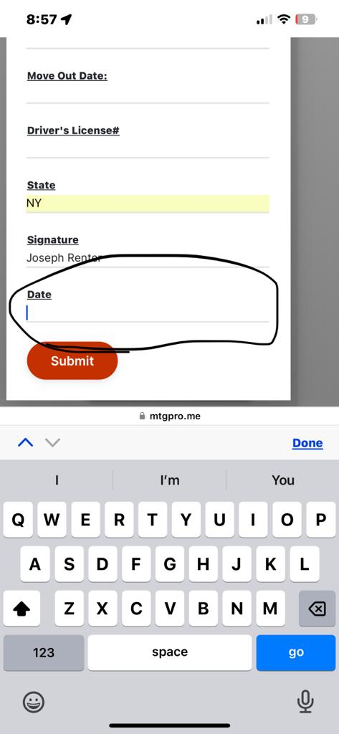

Crm reply - this does not look good. Cannot read email. Email is supposed to be spoofed from subscribers email and Cc subscriber. This is not working as originally reviewed

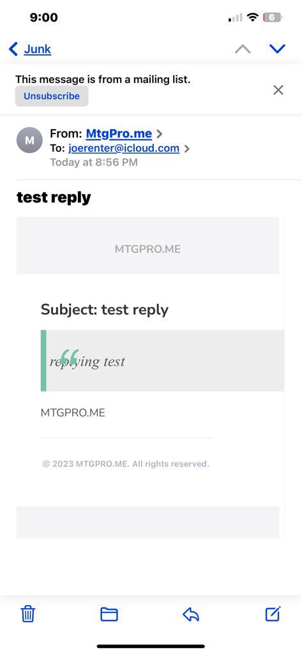

Needs to have:

Name

Email

Phone Number

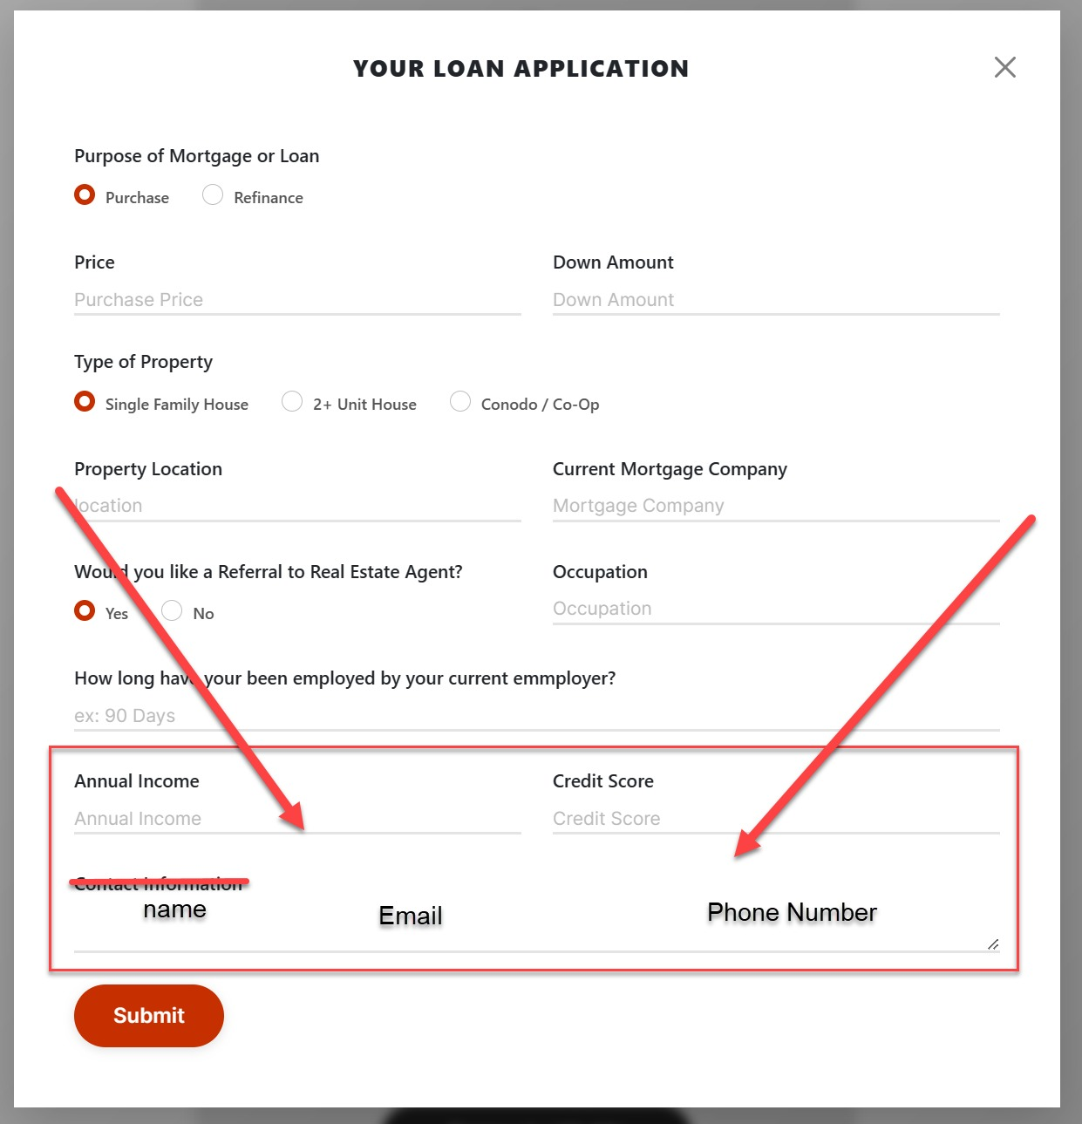

Would you like a Referral to a Real Estate Agent.  
the letter A before REAL is missing  
this is also only suppose to be in purchase, not refinance. There is no real estate agent in a refinance  
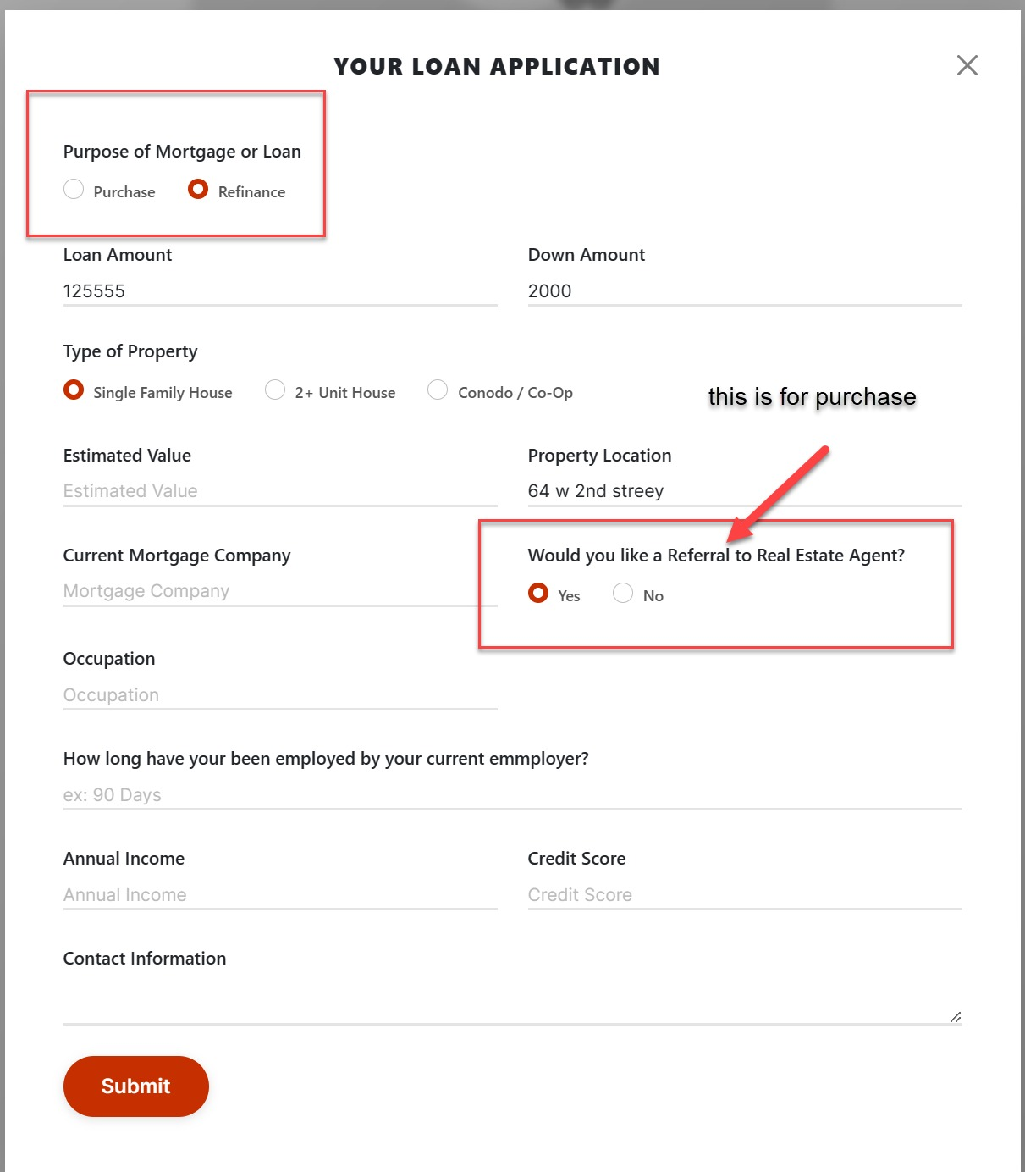

Current Mortgage Company is for Refinance, not for purchase

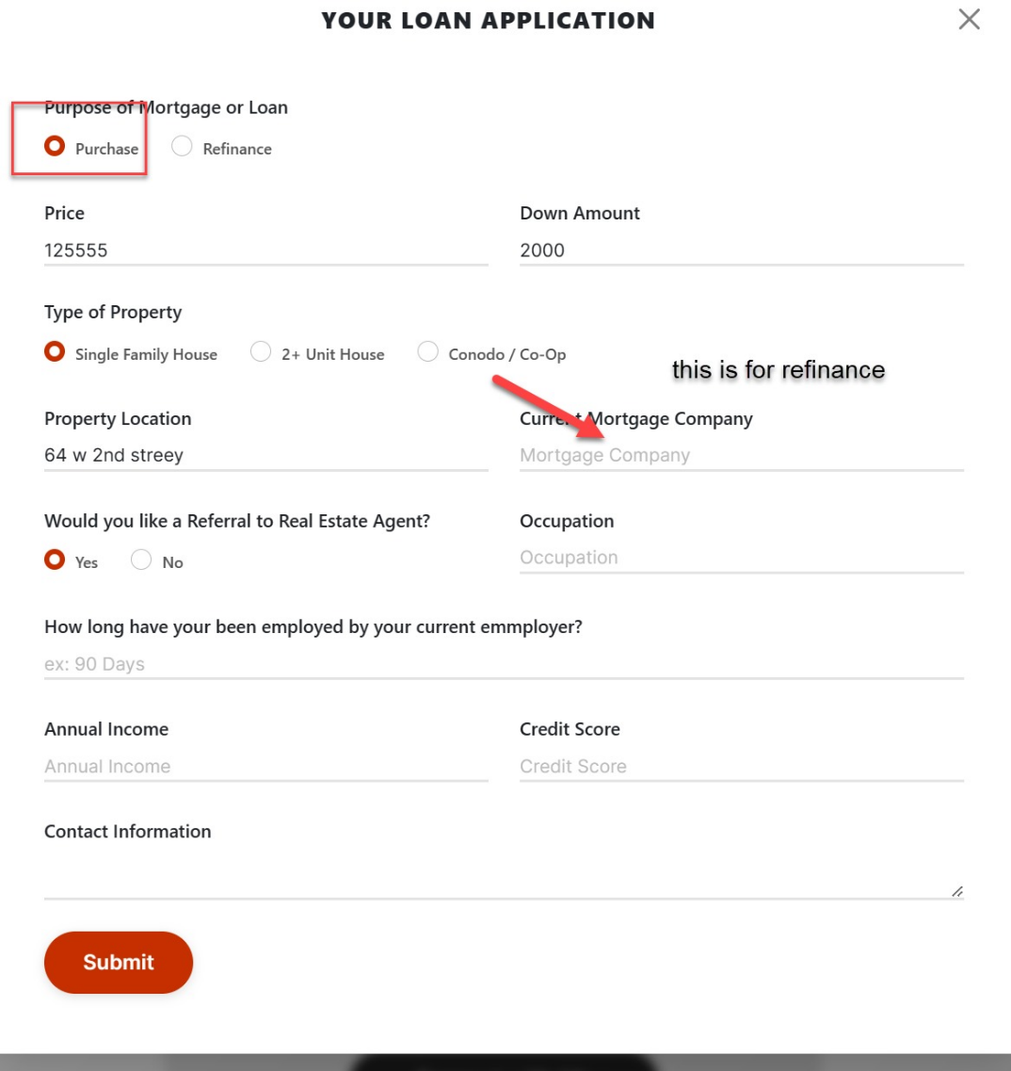

Down Payment is for purchase, not for Refinance.

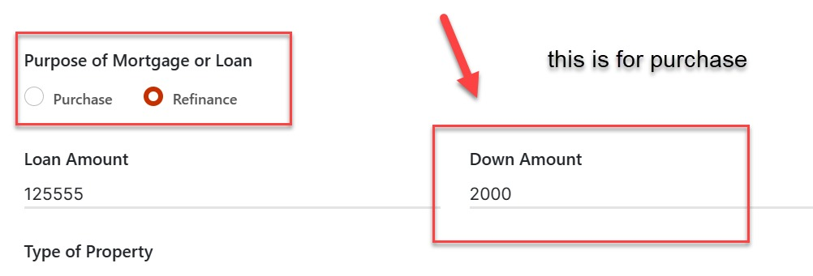

In Purchase (not Refinance) Verbiage should be

Purchase Price

Down Payment.

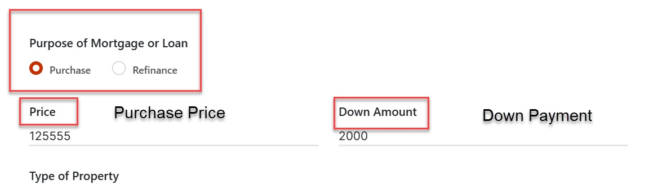

Submit in quick application is not going to email or in CRM either.

I was told this is working but it is not.

If it was working and now is that, that is a serious problem and proves the development is NOT stable.

Where is mortgage calculator?

It is misleading not seeing it here. It used to be, why is it not now?

User Disclaimer is only supposed to say Disclaimer, we went over this, it looks unprofessional

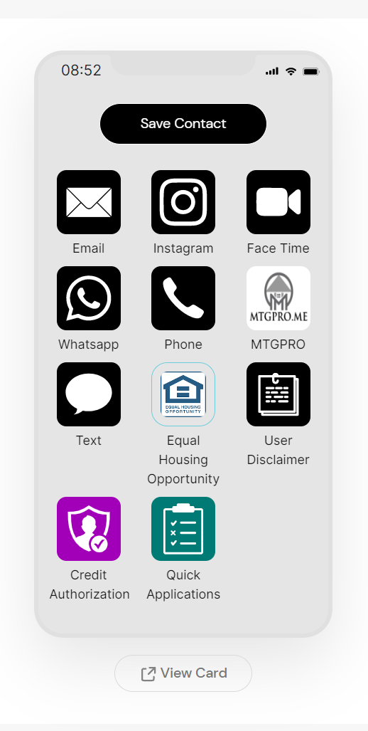

Can we relocate the text for the user disclaimer in the vcard edit and not in settings? This was NOT discussed but I think it would be easier to find and use.